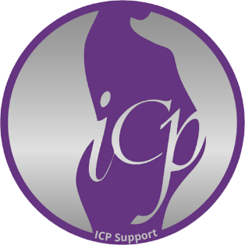

Gift Aid declaration – for past, present & future donations
Name of charity: ICP Support
I am a UK taxpayer and want ICP Support to treat the donations I have made in the past four years and all future donations as Gift Aid donations.
- I understand that my donation is only qualified for the scheme if I pay enough UK Income Tax, Capital Gains Tax or both to cover the amount of tax that all charities I donate to will reclaim in that tax year
- If I pay less it is my responsibility to pay back the difference
- I understand the charity will reclaim 25p of tax on every £1 that I give.
Donor’s details (*Indicates necessary information to reclaim tax)
Title -------------
*First name or initial(s) -----------------------------------------------------------
*Surname ------------------------------------------------------------------------------------------------
*Home address (including house name or number) ------------------------------------------
---------------------------------------------------------------------------------------------------------------
*Postcode ----------------------------------
*Date -----------------------------------------------------------------------
*Signature ----------------------------------------------------------------
Email address ------------------------------------------------------------
Please notify the charity if you:
- Want to cancel this declaration
- Change your name or home address
- No longer pay sufficient tax on your income and/or capital gains.

If you pay Income Tax at the higher or additional rate and want to receive the additional tax relief due to you, you must include all your Gift Aid donations on your Self Assessment tax return or ask HM Revenue and Customs to adjust your tax code.
Please print, complete, sign and return this form to:
ICP Support, 69 Mere Green Road, Sutton Coldfield B75 5BY
Registered in England No. 07817408; Charity registration number 1146449

